**Creating a Calendar Table Using the Power Query M-Language**

**Introduction**

Calendar Date table can be created in Power BI using mostly DAX. However, there might be reasons one might want to do the same using Power Query M language which might be for Model Performance reasons or convenience reasons. In this i have created the calendar date table using a Insert Column and the M language in Power Query.

**Steps for creating the calendar table**

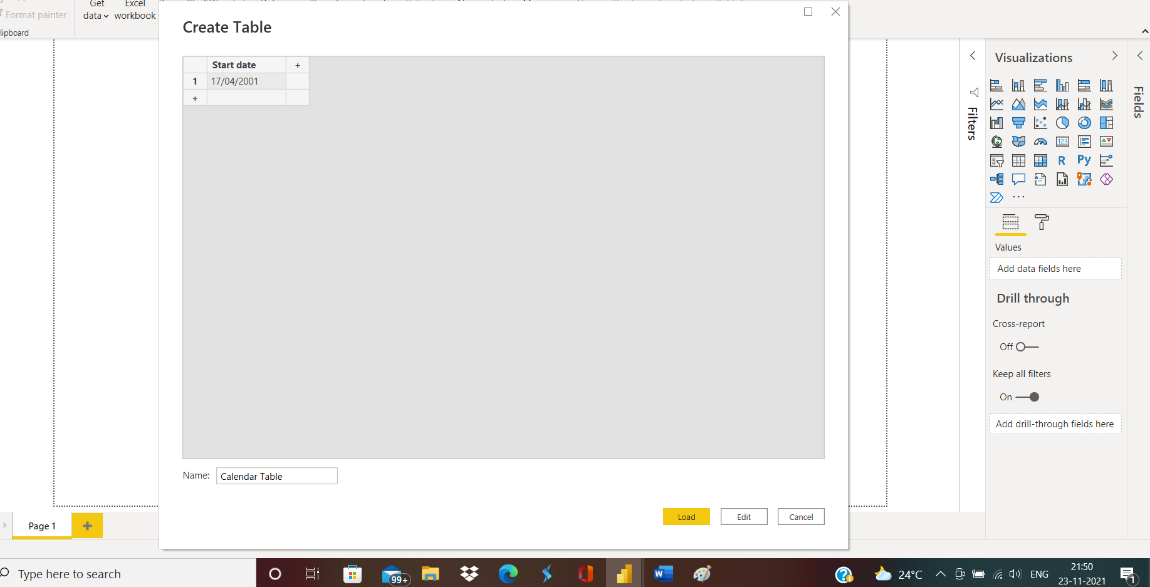**Step-1** Create a new table named **"Calendar table”** from the home tab using the enter data table.

**Step-2** Select the start date query and from the add column ribbon choose custom column option and create a column named "**End date**", then in the custom column formula type - **Date.From(DateTime.LocalNow())** and enter ok .

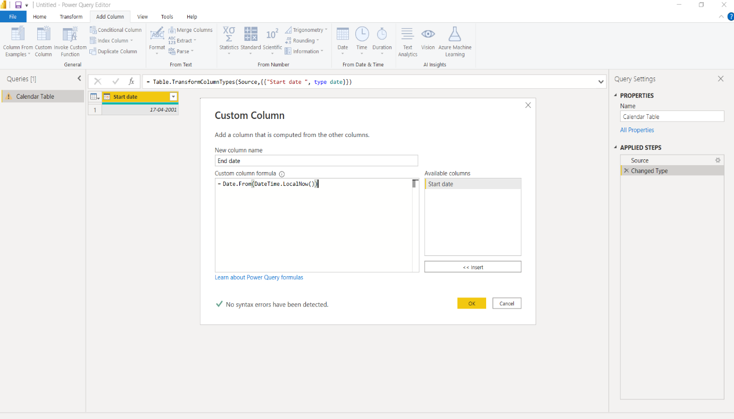

**Step-3** Change the datatype of both the columns to date type.

**Step-4** Again from the add column ribbon choose custom column name as **"Dates"** and enter the formula as **{Number.From([#"start date "])..Number.From([#"End date "])}** click ok , expand the Dates column to new rows , change the datatype . Delete the **start date**" and "**End date** columns .

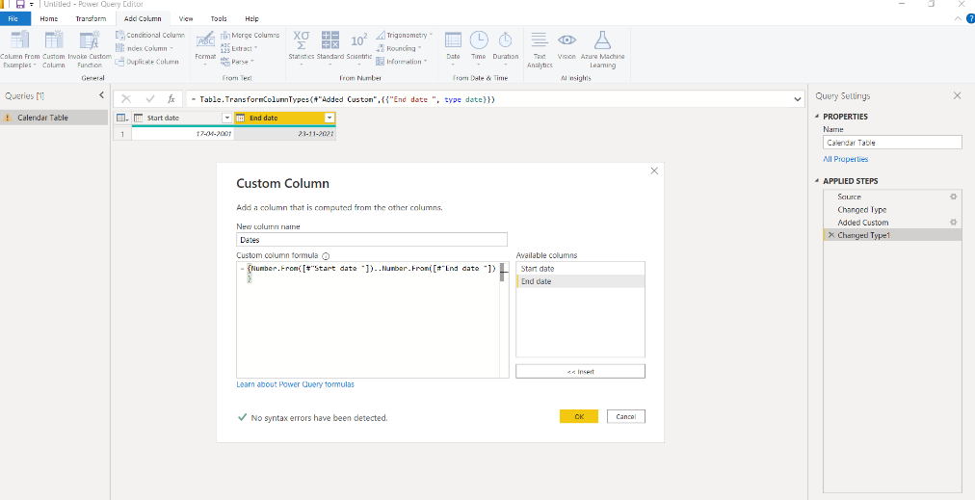

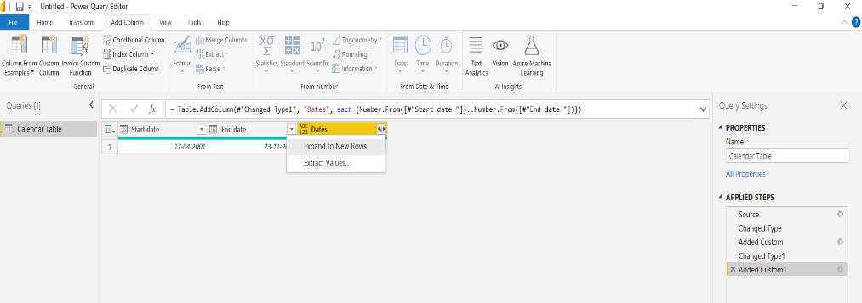

**Step-5** Load Calendar dates table to Power BI data model and add start of year , month, day, week, quarter etc from the Date options .

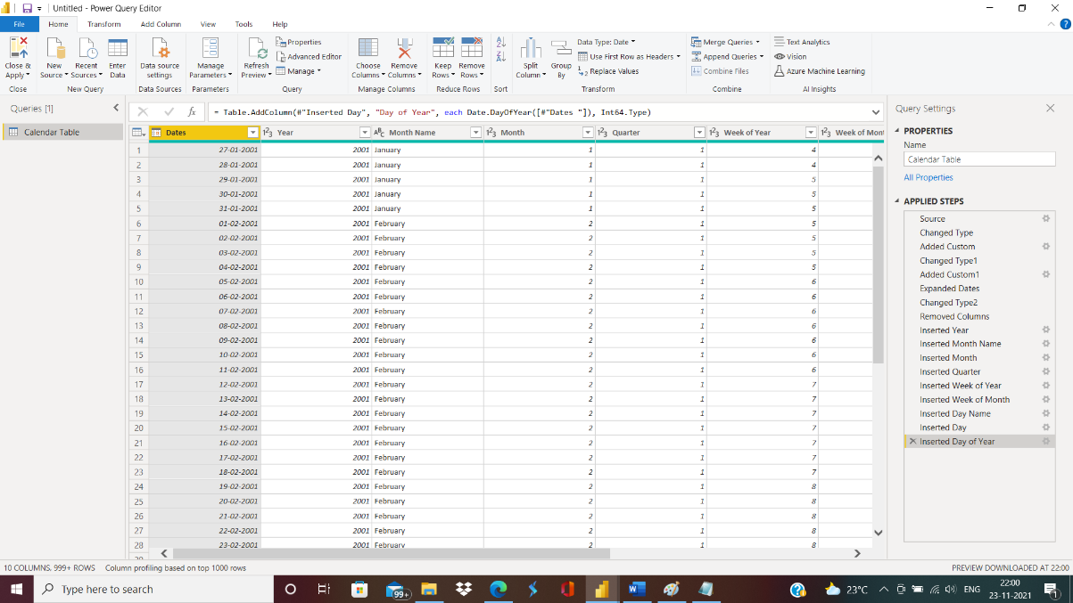

**Step- 6** Open the "Advanced Editor" window to see the full M code behind this Calendar table.

